**2023-1 Solid Mechanics Quiz #2**

(2023.06.01.)

『Please write all the answers on this test sheets. You can also use the back side for the answers.』

1. Determine the force in each member of the loaded truss. [20 Points]

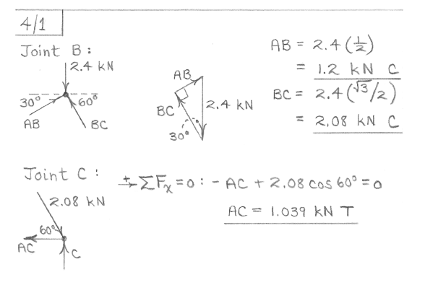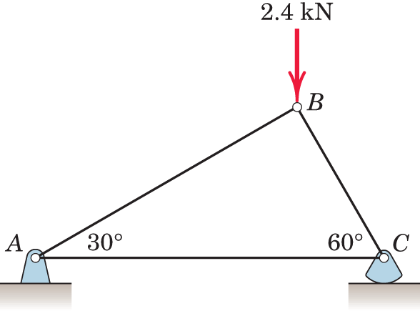

2. Determine the force in each member of the loaded truss. (g=9.81m/s2) [20 Points]

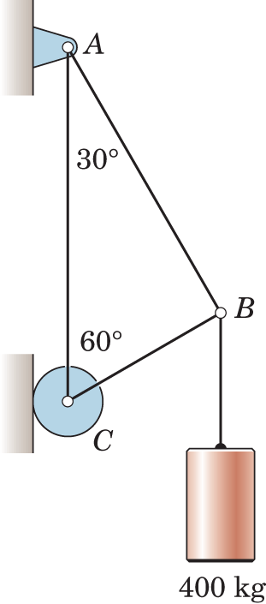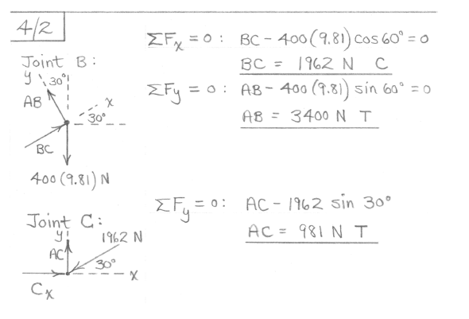

3. Determine the force in member CG. [20 Points]

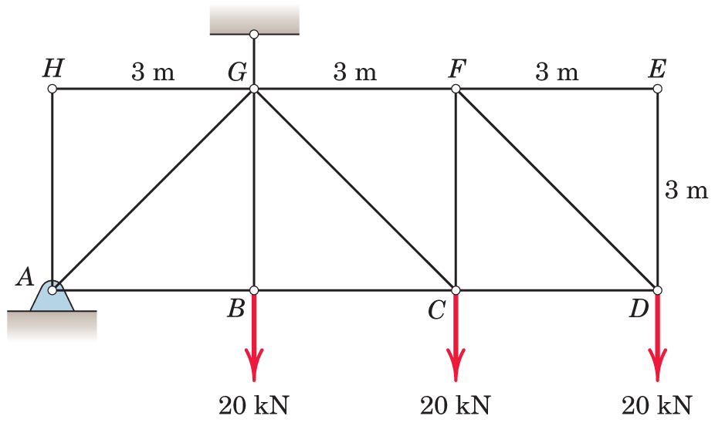

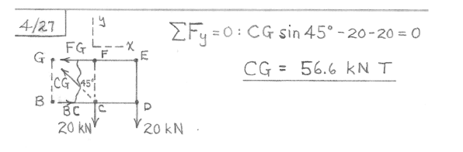

4. Determine the force in member AE of the loaded truss. [20 Points]

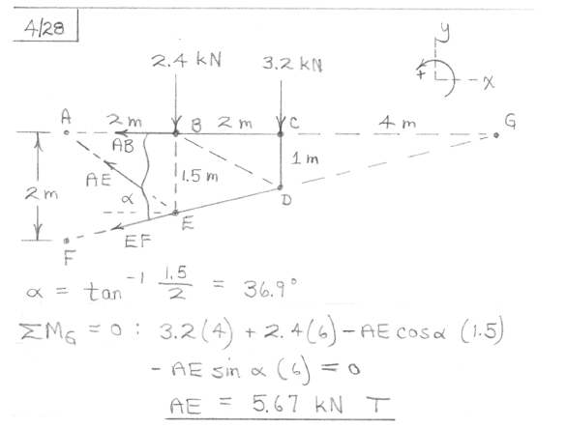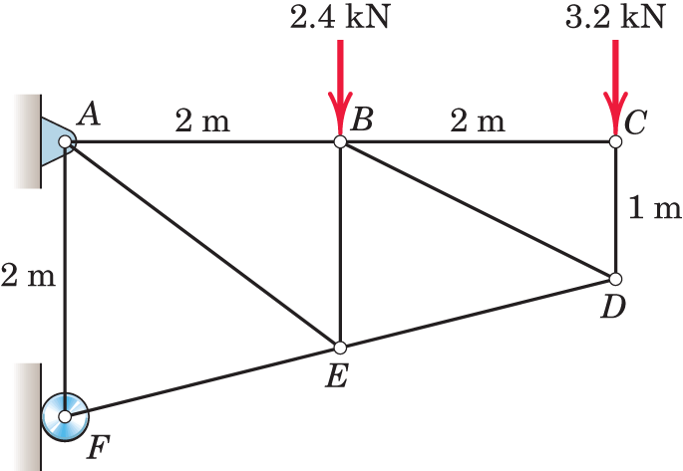

5. Determine the forces in members BC and CG. [20 Points]

